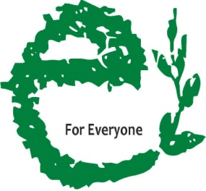

ANNUAL REPORT 15 - 16

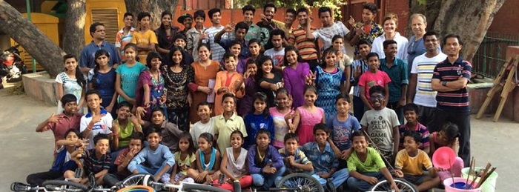
PRATYeK
338 Double Storey New Rajinder Place
New Delhi 110060 INDIA
+91-99-90-999640
ePRATYeK@gmail.com
www.PRATYeK.ngo

Table of Contents

- Organisation Profile..........……………………………………………….…………………….3
- Introduction to PRATYeK.........................................................…………….…4
- About PRATYeK(Objective ,Vision &Mission)............................................5
- NINEISMINE Campaign ......................................................………………..……6
- Our Programs...............................................................………………….……….7
- Achievements during the year............…………………………………………………19
- Financial Report.......……………………………………………………………………………20

ORGANISATION PROFILE

Name of the organisation: PRATYeK
Contact Person: Steve Rocha
Registered Office: 338, Double Storey New Rajinder Nagar New Delhi 110060 INDIA.
Operational Office: Office no. 301, F-46, Bhagat Singh Marg, New Delhi -110001 INDIA.
Telephone No: 011-23743095/6
Mobile N0: +91-9990999640
Website: www.pratyek.ngo
Email Address: epratyek@gmail.com
Registration No: S/605/2013
Act under which registered: Societies Registration Act 1860
Date of Registration: 9th October 2013
Registration under 12A:6, Gole Market Chowk, Sector 3, Sector 4, Gole Market, New Delhi, Delhi 110001
Registration under 80G:DEL-PE25305-02072014/5105
TAN No: DELP20535E
Bank Name: HDFC Bank
Bank Address:
Bank Branch & Code: Gole Market(0584)
Account No: 50100030278341
PAN NO: AACTP4190N

- Introduction
PRATYeK is a registered society with an emphasis on ‘Presence and Ruthfulness for Advocacy and Training of the Young in Earth-rights and Kids-rights’. PRATYeK in Hindi means ‘every being’ and it captures the essence of providing all rights and opportunities to every child in India if not every being of our earth community.
PRATYeK attempts to educate children and their care providers in the art of advocacy and justice with a focus on child-rights and earth rights. PRATYeK seeks to include tools and resources for advocacy and social justice skilling in school curricula to raise awareness amongst children to groom young people into compassionate, conscientious and proactive ‘kidizens’. PRATYeK recognizes children as primary stakeholders of society and therefore seeks to provide them with local, national and international forums towards effectively engaging with policies, policy makers while ensuring the effective implementation of the same. PRATYeK coordinates a larger network of child rights organizations and networks with a presence in practically every state and union territory of India.
PRATYeK is the Presence of Edmund Rice International in India. This network gives PRATYeK access to schools across the world. PRATYeK supplements this network with its own network of global schools and child rights organizations.
PRATYeK’s principal modus operandi is networking and collaboration which enables it to reach out to schools, child right organisations and their children and their young beneficiaries right across all states and union territories of this country.

- OBJECTIVE
The aim of the Society is to assist, promote, channelize, undertake, educational, medical, relief of the poor, social, charitable and humanitarian work irrespective of caste, community and economic status, solely for philanthropic purpose and not for the purpose of profit …’ (as extracted from the Memorandum of Association of PRATYeK)
- VISION & MISSION
The Vision of PRATYeK is thus Educating Every Child for Every Right for Everyone’
The Mission of PRATYeK is as follows:
E stands for Edmund,
Education,
Empowerment, and
Equity
for the Earth
for Every right
for Every Child …..
for Everyone.

The Ultimate goals of PRATYeK’s 2020 vision statement reads:
- Educating for Liberation
- Enfleshing Advocacy
- Enabling Partnership
- Empowering Collaboration
- Engaging with Power

Governing Board of PRATYeK
S.no | Designation | Name
1. | President | Ralph Sequeira
2. | Vice President | Augustine Jairaj
3. | Secretary | Steve Dom Rocha
4. | Treasurer | Edwin D’souza
5. | Executive Committee member | Joaquim Anthony Johnson
6. | Member | Osmand Ballyntyne
7. | Member | Stanley Gerard Alvarez
8. | Member | Gordon Theodore Gale
9. | Member | David Ryan Silva
10. | Member | Mark DaCosta
11. | Member | Conrad D’Souza

NINEISMINE Campaign
NINEISMINE is a campaign for child rights convened by PRATYeK for the WNTA (Wada Na To Abhiyan). It is a participatory children’s advocacy initiative to call for 9% of the Gross Domestic Product (GDP) to be committed to health and Education as promised in the Common Minimum Program of 2004.
This initiative of children, schools, communities and organizations across all the states and Union Territories of India to hold the government accountable to its promise to end poverty, Social exclusion and discrimination-towards meeting the United Nations Sustainable Development Goals.
The purpose of NINEISMINE is to put children from across the country at the centre of advocacy efforts-speaking in one voice to enable every child to enjoy basic health care and quality education as their non-negotiable right. The campaign roots itself in actualizing the spirit and intention of the Convention on the Rights of the Child (CRC). So while the Campaign seems centred around every Child’s Right to Quality Education (CRC Article 28), Health (CRC Article 24) and their Rights against Exploitation and Exclusion (CRC Articles 32-40) the campaign is particularly focused on Right to Participation and HOW these rights are delivered or attained.
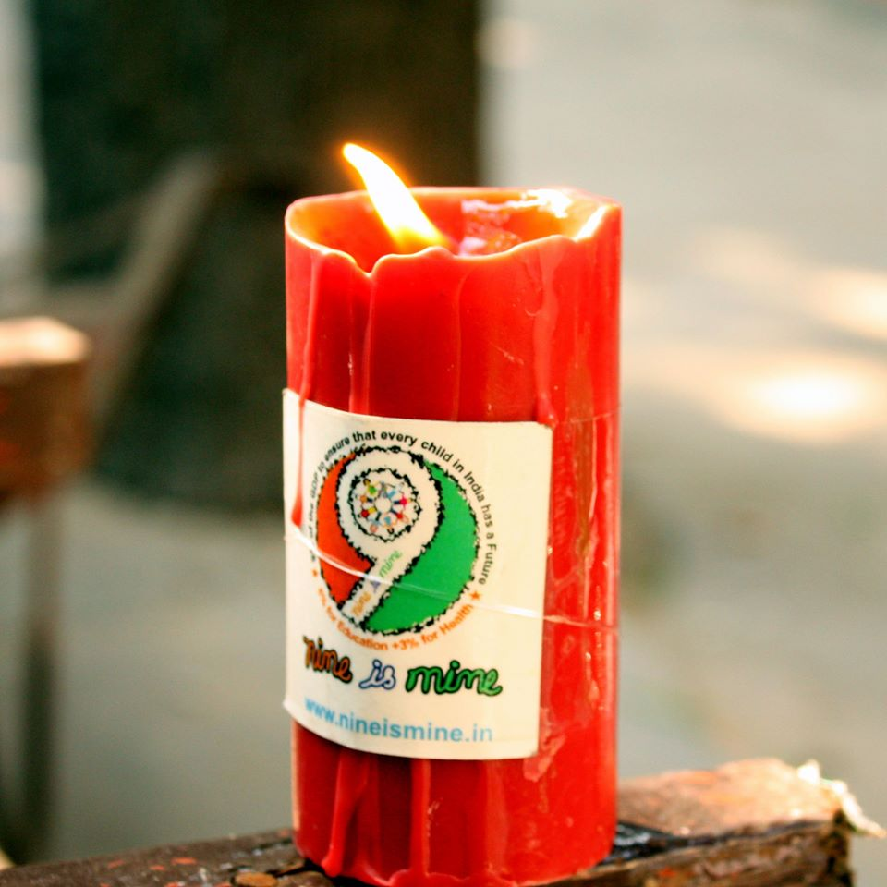
The NINEISMINE campaign is being designed as one that is of for and by the children. A child’s Right to participation through democratic means is at the heart of this initiative. Children are given platforms to speak for themselves through created child friendly media. These include juggling, circus art, mime, football, dance etc. the NINEISMINE campaign also believes that while children from marginalised situations and communities would be at the heart of its endeavours, children from privileged situations would also share these forums in the spirit of inclusion.
The NINEISMINE campaign believes that a ‘child who is capable of forming his or her own views’ has ‘the right to express those views freely in all matters affecting the child,’ and that the views of the child be given due weight ……’Even in “judicial and administrative proceedings affecting the child”. The campaign provides children to access those structures already available under our democratic system. The campaign agrees that though children ‘may not be voters…..the voices of children can be stronger than the votes of adults.’
The NINEISMINE campaign does not believe that children are ‘future citizens’ of India. It Believe that they are equal and active participants of India today. If so they have the right to participate fully in all aspects of democracy including that of “governance accountability”

The NINEISMINE campaign believes in creating platforms for all children to interact and dream of a better more Equitable and Inclusive world. However, it does believe that spaces must be created for vulnerable voices to be heard, children with access to more resources are invited to provide their spaces, talents and networks to work with rather than for their marginalized peers. The NINEISMINE campaign however, is cautions not to use children’s voices to propagate adult’s views and aspirations. Hence it has intended to keep the goals simple and non-controversial.
The NINEISMINE campaign grew out of Nelson Mandela’s call to ordinary citizens to keep governments accountable to fulfilling the MDGs. Children in India took upon themselves the task to ensure the fulfilment of Goals 2 and 3 and 4 – all of which refer to children. Later the campaign grew to realize the exclusion issue of children particularly in the context on India. They therefore incorporated a strong focus on the last child. However, keeping alive the need to ensure that all sections of India (the children of privileged middle-class and excluded communities) all interact together to find common solutions.

HAQKISHOR
Highlight: Regular advocacy training sessions with children and current issues of child rights
NINEISMINE is a campaign of for and by the children of India that attempts to train children in the art of advocacy on social issues and environment. Every month therefore the campaign attempts to gather children from varied schools and child rights organisations while providing them the skills and information of varied democratic platforms and social issues. HAQKISHOR is a pun that implies both child rights and children attempts to claim the same. These sessions are held regularly in the capital and on some occasions in varied centres in the country.
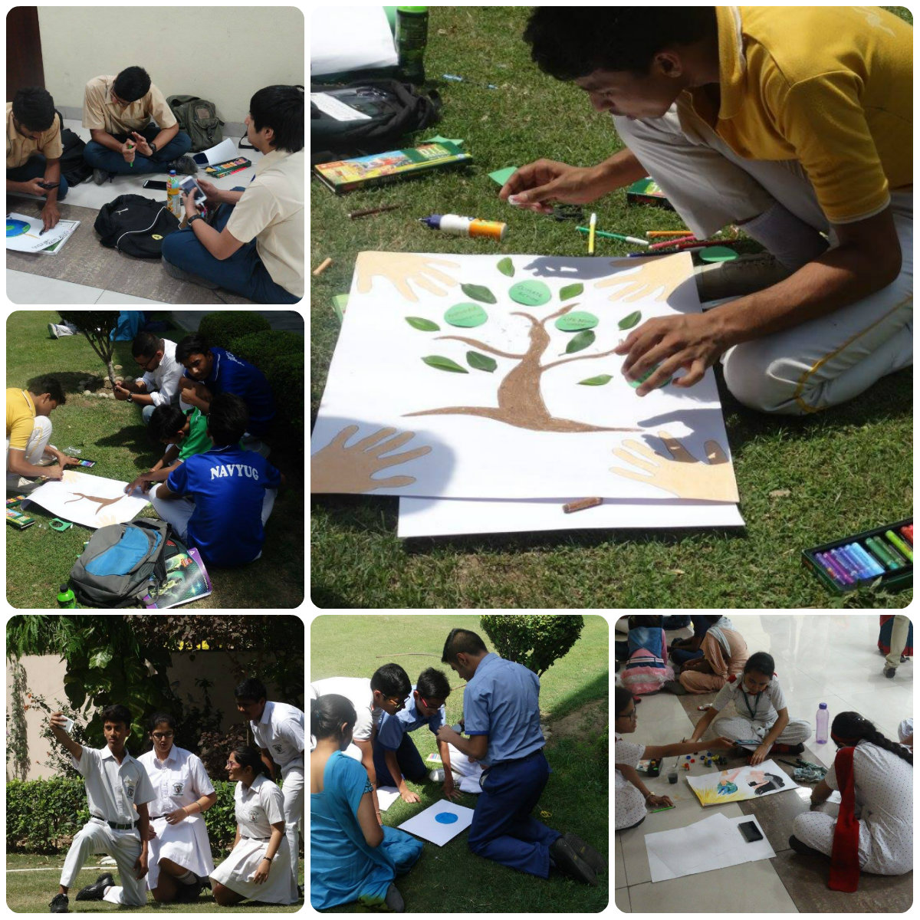

PLAY FOR PEACE
Conducted on the 28th and 29th of July 2015 during the Yash Camp. CSEI (Centre for Social Equity and Inclusion conducted a game called Play for Peace where 40-50 children from the Yash group participated in the game interacting with each other and getting to know the different cultures and people.

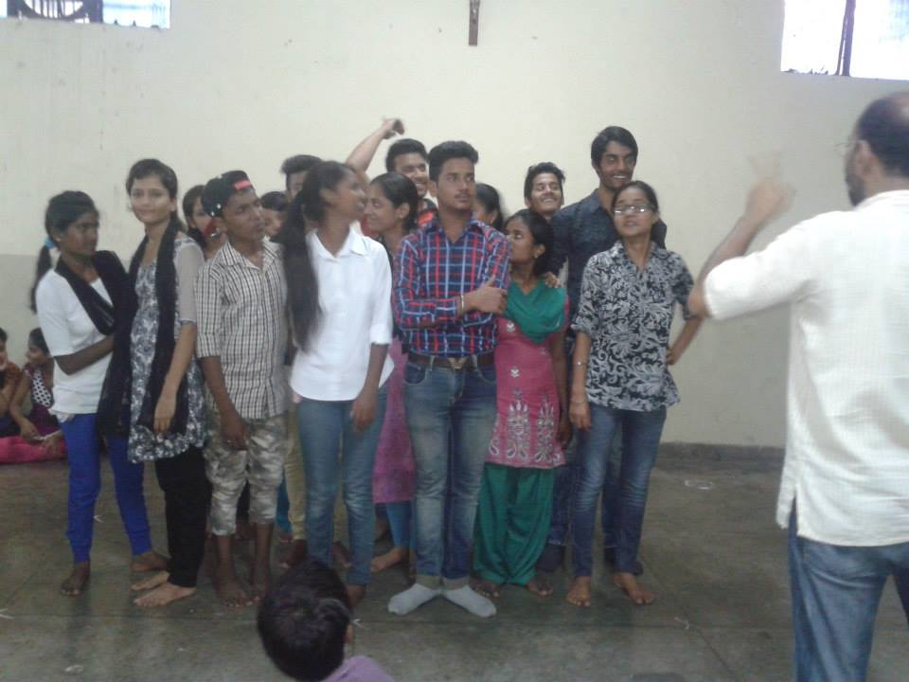

CHILDRENS PARLIAMENT
Children’s parliament is a parliament which consists of different designated members who are elected by participants who are every child below the age of 18 from a particular area or locality. The children’s parliaments have discussions on any problems being faced in the locality and find ways of solving it. On the 21st and 23rd of May 2015 a children’s Parliament took place at St.Coloumbas where children from the Yash group were the participants, there was an explanation on what the children’s parliament is all about and also members were elected. It was conducted in partnership with Chetanalaya also an organisation working for Child Rights.
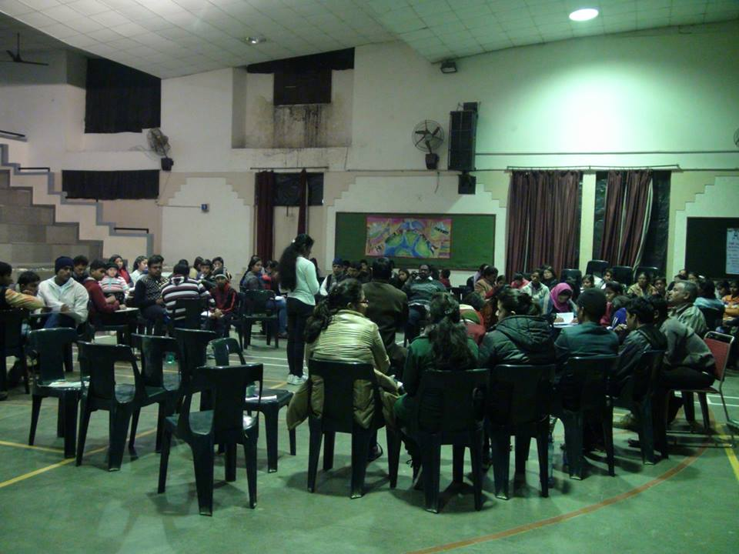

UN VOLUNTEERS MEETING
The programme was organized by the UN Volunteers and Brother Steve and Astha staff from NINEISMINE attended the programme where civil societies from across India came together for a Reflection on the UN My world Survey process and the NINEISMINE campaign was asked to share their experience in gathering the offline voices or the voices of 1,20,000 children across India.

SIGN LANGUAGE TRAINING
ON the 11th of July, 2015 Sai Swayam Sewa (SSS) organised training on Sign Language for the staff of NINEISMINE and UNGA team. One of the child from the UNGA team had hearing impairment and as such the team decided to learn sign language in order to connect with him.
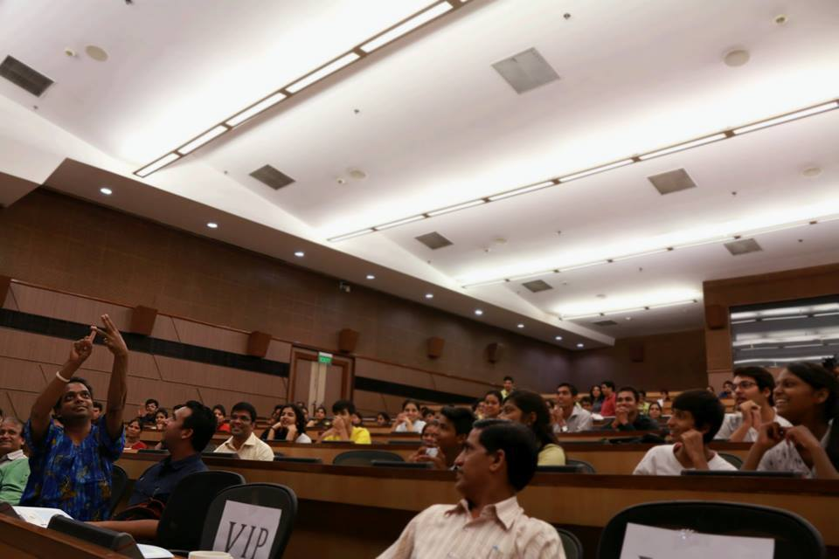

PLAY IT SAFE
Mumbai Play it safe is an opinion Poll that took place in Maharashtra along with Mumbai Smiles and The UNICEF Maharashtra, representatives from the NINEISMINE campaign namely, Sarah Fernandes and Jessica Azavero coordinated 5000 responses of children across 8 districts of Maharashtra.

WORKSHOP IN HYDERABAD
The Workshop in Hyderabad was attended by two young Child Advocates Sorun and Umesh accompanied by Denzil who is a staff at NINEISMINE. The workshop was organised by PARA ( Peoples action for rural Awakening) and was based on Human Rights Club for the South Zone of India where new members were elected for the Human Rights Club. Nearly 400 children attended the workshop and the NINEISMINE team conducted a session on UPR( Universal Periodic Review).

JANTAR MANTAR PROGRAMME
On 24th April, there was a review of public on the NDA Governance for a year, different Social Activists and Congress Minister Jairam Ramesh spoke on the one year Governance of the NDA Government. The children from the Yash group performed the circus art highlighting Child Rights.
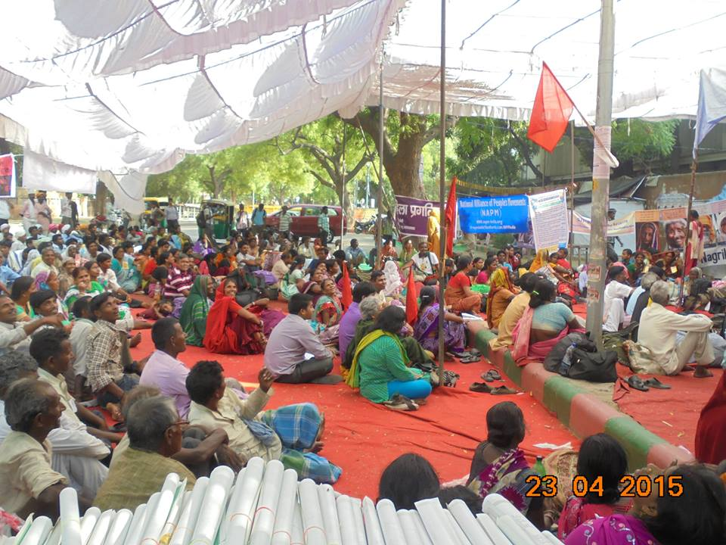

IMMERSION FROM ST.JOSEPHS AND ST. ADENS
A group of students came to India to see how NINEISMINE works and know more about Indian Culture and Child Rights in India. The work was explained through a presentation and both the groups got to be part of a cultural programme that happened at Central Park in Cannaught Place with OBR (One Billion Rising) which was on violence against women. They also interacted with the children from the Yash group who are children below the age of 18 from the slum area around Central Delhi; the children also performed the circus art.
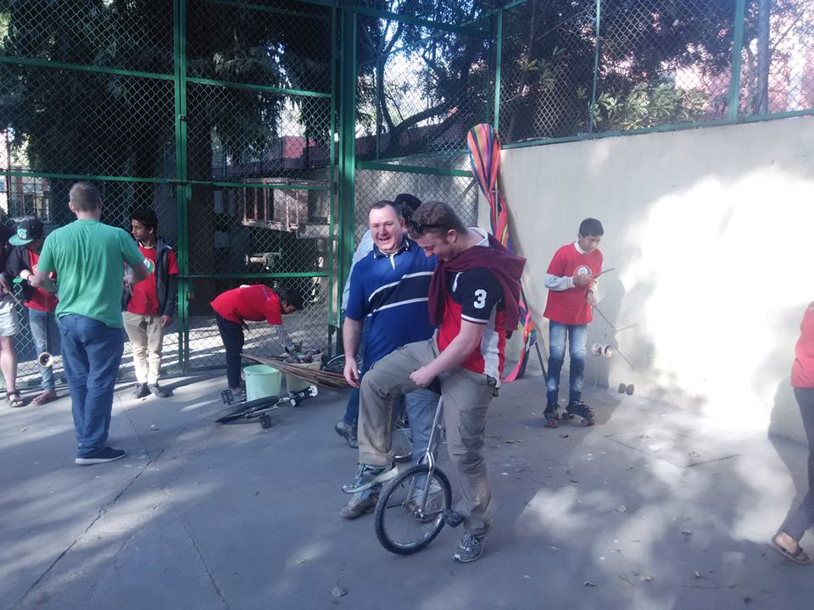

ONE GOAL
From the 14th to the 17th of May 2015 there was a programme organised by NINEISMINE and World Vision to promote health issues through football, different NGO workers from different states came together at one place and learnt about the various health problems that children face and how to train children football to have a healthy life style. The programme took place at St.Coloumbas where NINEISMINE and World Vision Staff also had a football match.
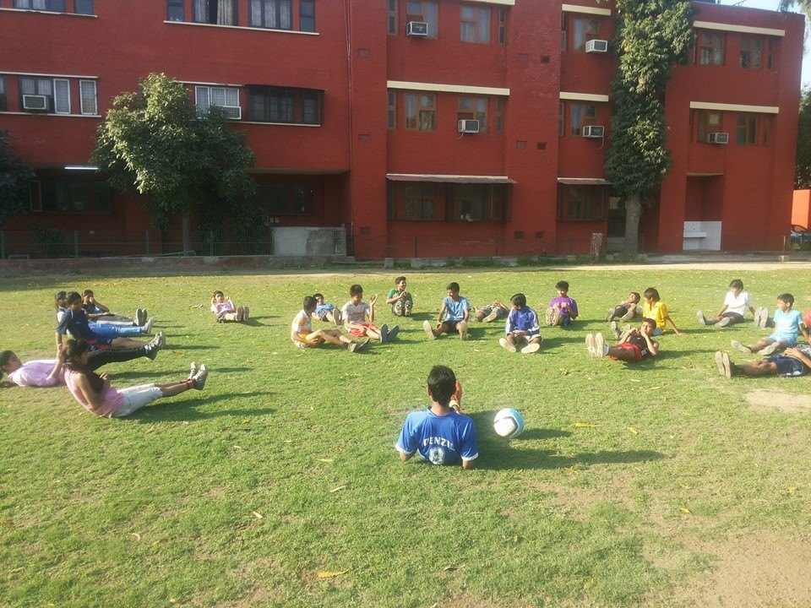

IACR WORKSHOP
IACR organises various discussion groups to talk about child rights and the issues that affect children. The NINEISMINE staff attended the discussion on Child Rights Stocktaking organised on the 29th January. In that discussion various points and recommendation were put forward to influence the National Action Plan for Children.

ONE BILLION RISING EVENT
The program was organised by the One Billion Rising community in collaboration with many other organisation. The overall aim of the movement is to stop violence against women and promote the idea of gender equality. The children from the Yash group also participated supporting the cause of the OBR as well as promoting child rights. We also had a tribal group who joined us and performed a tribal performance. Hence, the OBR platform was used to talk about inclusivity and spread awareness about Child Rights and also the Global Sustainable Development Goals.
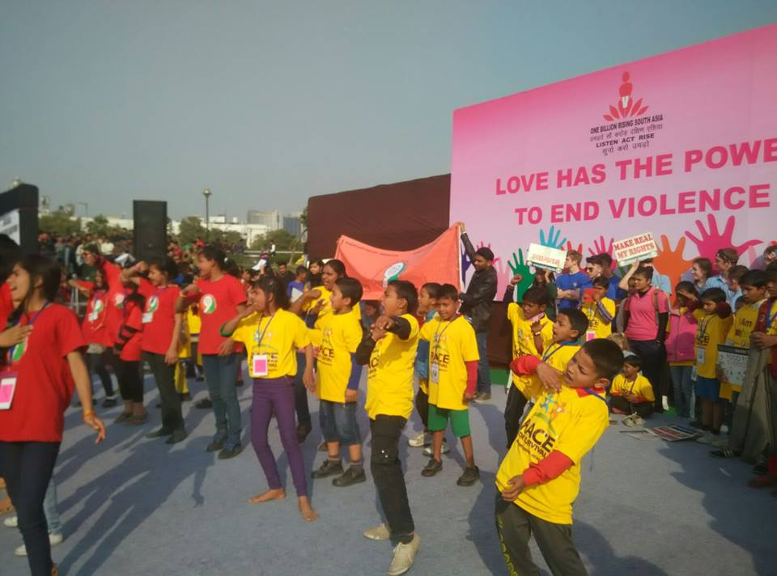

PEOPLES MARCH IN DEFENCE OF THE REPUBLIC
The event was organised by Anhad along with some other organisations and eminent people on the 30th January. The movement was deeply concerned with the grave assaults mounted on the republic. The idea was to make people aware and uphold the values of the constitution and also fight against the forces that would lead to the unmaking of the republic. A huge gathering was witnessed at the Jantar Mantar. A large number of organisations joined the movement supporting the cause and the idea behind it.

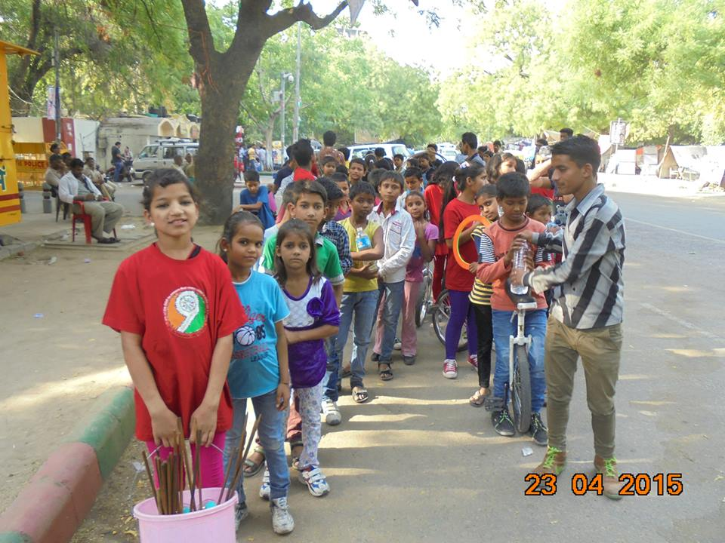

SEYMOUR COLLEGE VISIT, ADELAIDE
Seymour College from Adelaide visited the NINEISMINE team as part of their immersion program. They were here for a week and in that, they interacted with the children from the Yash group through various activities. Various games and other interactive and learning sessions were conducted to enhance the learning capacity of the children. A slum to the mall walk was also conducted to sensitize the group and make them aware of the real concept of the development.
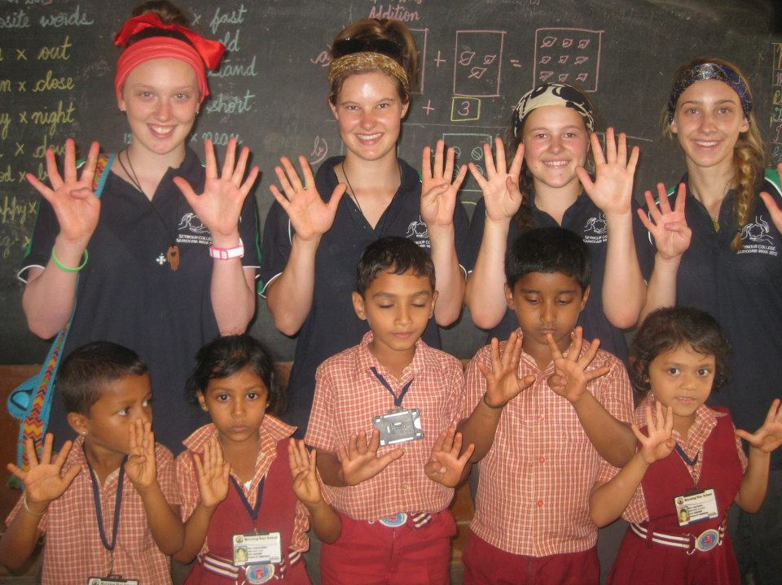

HELP DELHI BREATHE
Help Delhi Breath was an event organised by a group of individuals along with some other organisations to work towards solutions regarding the rising air pollution levels in Delhi. The children from the Yash group joined the movement endorsing the concept and expressing their concern and asking the people as well as the Government to be aware and help reverse climate change by taking small steps and improve the air quality so that people can lead a healthy life.
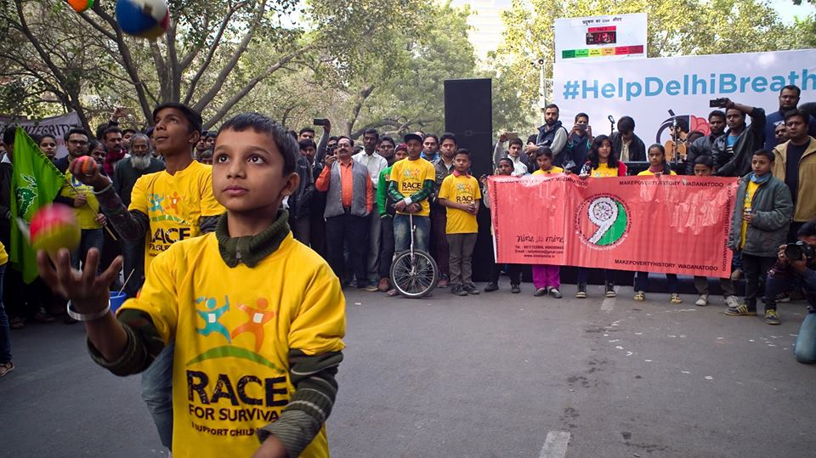

COLLABORATION
• One of the Staff members from the NINEISMINE along with a child advocate named Souran from the Yash group attended a three day workshop in Ahmedabad, Gujarat with Shaishav organisation about the importance of children’s club in each community and organisation and how it will help them to be leaders of today and tomorrow.

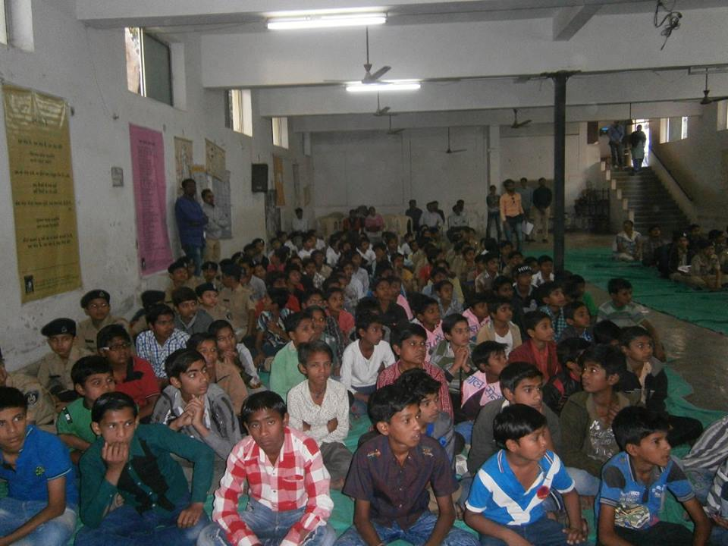

• IPYG from Korea organized a gathering in Delhi with some Religious leaders of different communities and it was based on how religious leaders help in all countries to live in Peace and what actions can be taken. NINEISMINE Staff member Denzil attended the programme.
• On the 21st of February two young advocates Sorun and Umesh accompanied by a NINEISMINE staff member attended a workshop in Hyderabad organised by Para (Peoples Action for Rural Awakening). The workshop was on Human Rights Club for South Zone of India. 400 children attended the workshop and the NINEISMINE team also conducted a UPR (Universal Periodic Review) workshop with the 400 children from the south zone.

RAHIGIRI
It is an event that happens every Sunday at Connaught Place organised by NDMC (New Delhi Municipal Corporation). It is a platform where anyone an individual or a group can come and showcase their talent.
The NINEISMINE staff along with the children from the Yash group take part in the Rahagiris’ on a regular basis. Some of the Rahagiris that the team was a part of were Pope for planet, one was in collaboration with Water Aid and UNICEF there was also one on Climate change.

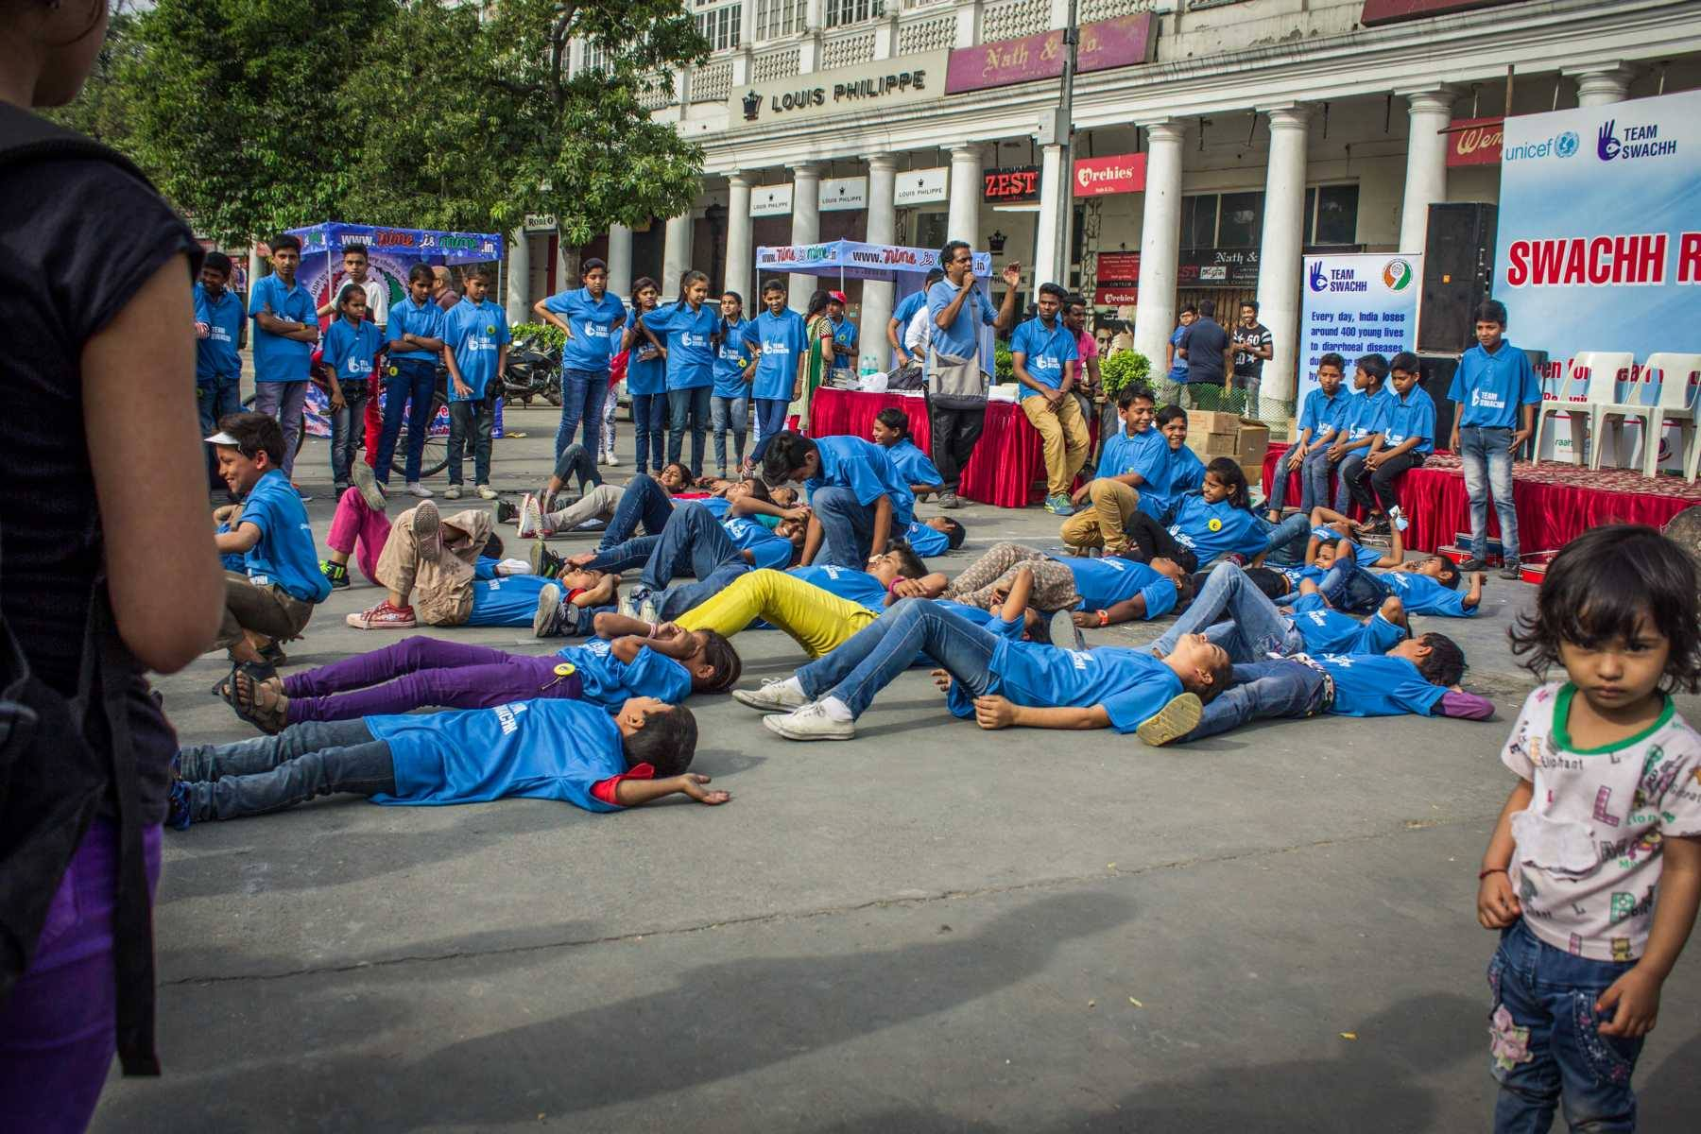

MONTHLY MAILS
Highlight: An Initiative to build the network among schools while their awareness on social issues is raised
Occasional monthly assemblies are created and circulated among schools and NGOs on relevant social issues usually on significant national and international days. This is a medium to keep the network alive and connected to the campaign. Some of the social issues touched upon are child mortality, water and sanitation, poverty, the MDGs, Nelson Mandela Day and malnutrition.

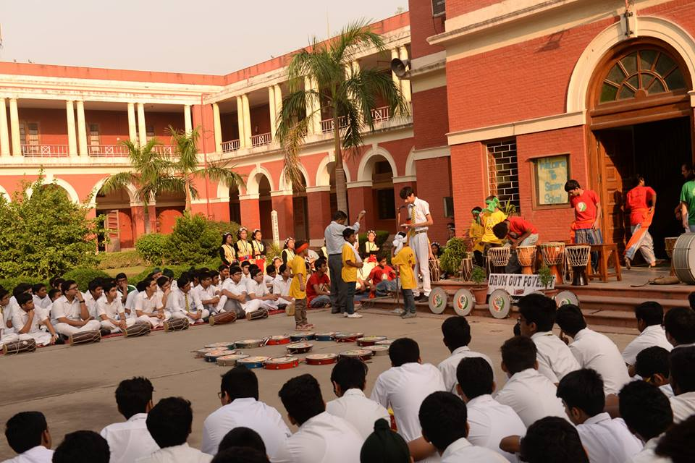

GAME TO END POVERTY
Game to end poverty is an event organised on Child Rights day. During this event Students, Principal’s, Cooperates and Ambassadors gathered together to play different games based on the goals.

