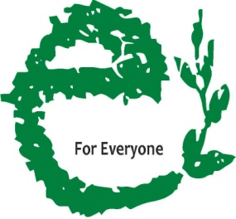

ANNUAL REPORT 14 - 15

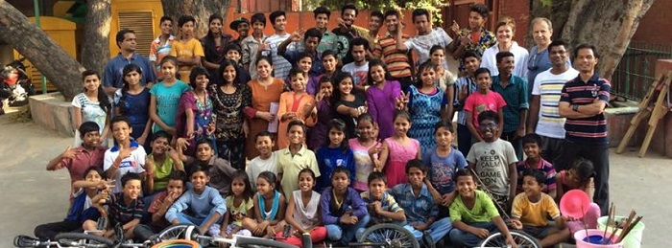
PRATYeK
338 Double Storey New Rajinder Place
New Delhi 110060 INDIA
+91-99-90-999640
ePRATYeK@gmail.com
www.PRATYeK.ngo

Table of Contents

- Organisation Profile..........……………………………………………….…………………….3
- Introduction to PRATYeK.........................................................…………….…4
- About PRATYeK(Objective ,Vision &Mission)............................................5
- NINEISMINE Campaign ......................................................………………..……6
- Our Programs...............................................................………………….……….7
- Achievements during the year............…………………………………………………19
- Financial Report.......……………………………………………………………………………20

ORGANISATION PROFILE

Name of the organisation: PRATYeK
Executive Director: Steve Rocha
Registered Office: 338, Double Storey New Rajinder Nagar New Delhi 110060 INDIA.
Operational Office: Office no. 301, F-46, Bhagat Singh Marg, New Delhi -110001 INDIA.
Telephone No: 011-23743095/6
Mobile N0: +91-9990999640
Website: www.pratyek.ngo
Email Address: epratyek@gmail.com
Registration No: S/605/2013
Act under which registered: Societies Registration Act 1860
Date of Registration: 9th October 2013
Registration under 12A: 6, Gole Market Chowk, Sector 3, Sector 4, Gole Market, New Delhi, Delhi 110001
Registration under 80G: DEL-PE25305-02072014/5105
TAN No: DELP20535E
Bank Name: HDFC Bank
Bank Address:
Bank Branch & Code: Gole Market (0584)
Account No: 50100030278341
PAN NO: AACTP4190N

- Introduction
PRATYeK is a registered society with an emphasis on ‘Presence and Ruthfulness for Advocacy and Training of the Young in Earth-rights and Kids-rights’. PRATYeK in Hindi means ‘every being’ and it captures the essence of providing all rights and opportunities to every child in India if not every being of our earth community.
PRATYeK attempts to educate children and their care providers in the art of advocacy and justice with a focus on child-rights and earth rights. PRATYeK seeks to include tools and resources for advocacy and social justice skilling in school curricula to raise awareness amongst children to groom young people into compassionate, conscientious and proactive ‘kidizens’. PRATYeK recognizes children as primary stakeholders of society and therefore seeks to provide them with local, national and international forums towards effectively engaging with policies, policy makers while ensuring the effective implementation of the same. PRATYeK coordinates a larger network of child rights organizations and networks with a presence in practically every state and union territory of India.
PRATYeK is the Presence of Edmund Rice International in India. This network gives PRATYeK access to schools across the world. PRATYeK supplements this network with its own network of global schools and child rights organizations.
PRATYeK’s principal modus operandi is networking and collaboration which enables it to reach out to schools, child right organisations and their children and their young beneficiaries right across all states and union territories of this country.

- OBJECTIVE
The aim of the Society is to assist, promote, channelize, undertake, educational, medical, relief of the poor, social, charitable and humanitarian work irrespective of caste, community and economic status, solely for philanthropic purpose and not for the purpose of profit …’ (as extracted from the Memorandum of Association of PRATYeK)
- VISION & MISSION
The Vision of PRATYeK is thus Educating Every Child for Every Right for Everyone’
The Mission of PRATYeK is as follows:
E stands for Edmund,
Education,
Empowerment, and
Equity
for the Earth
for Every right
for Every Child …..
for Everyone.

The Ultimate goals of PRATYeK’s 2020 vision statement reads:
- Educating for Liberation
- Enfleshing Advocacy
- Enabling Partnership
- Empowering Collaboration
- Engaging with Power

Governing Board of PRATYeK
S.no | Designation | Name
1. | President | Ralph Sequeira
2. | Vice President | Augustine Jairaj
3. | Secretary | Steve Dom Rocha
4. | Treasurer | Edwin D’souza
5. | Executive Committee member | Joaquim Anthony Johnson
6. | Member | Osmand Ballyntyne
7. | Member | Stanley Gerard Alvarez
8. | Member | Gordon Theodore Gale
9. | Member | David Ryan Silva
10. | Member | Mark DaCosta
11. | Member | Conrad D’Souza

NINEISMINE Campaign
NINEISMINE is a campaign for child rights convened by PRATYeK for the WNTA (Wada Na To Abhiyan). It is a participatory children’s advocacy initiative to call for 9% of the Gross Domestic Product (GDP) to be committed to health and Education as promised in the Common Minimum Program of 2004.
This initiative of children, schools, communities and organizations across all the states and Union Territories of India to hold the government accountable to its promise to end poverty, Social exclusion and discrimination-towards meeting the United Nations Sustainable Development Goals.
The purpose of NINEISMINE is to put children from across the country at the centre of advocacy efforts-speaking in one voice to enable every child to enjoy basic health care and quality education as their non-negotiable right. The campaign roots itself in actualizing the spirit and intention of the Convention on the Rights of the Child (CRC). So while the Campaign seems centred around every Child’s Right to Quality Education (CRC Article 28), Health (CRC Article 24) and their Rights against Exploitation and Exclusion (CRC Articles 32-40) the campaign is particularly focused on Right to Participation and HOW these rights are delivered or attained.
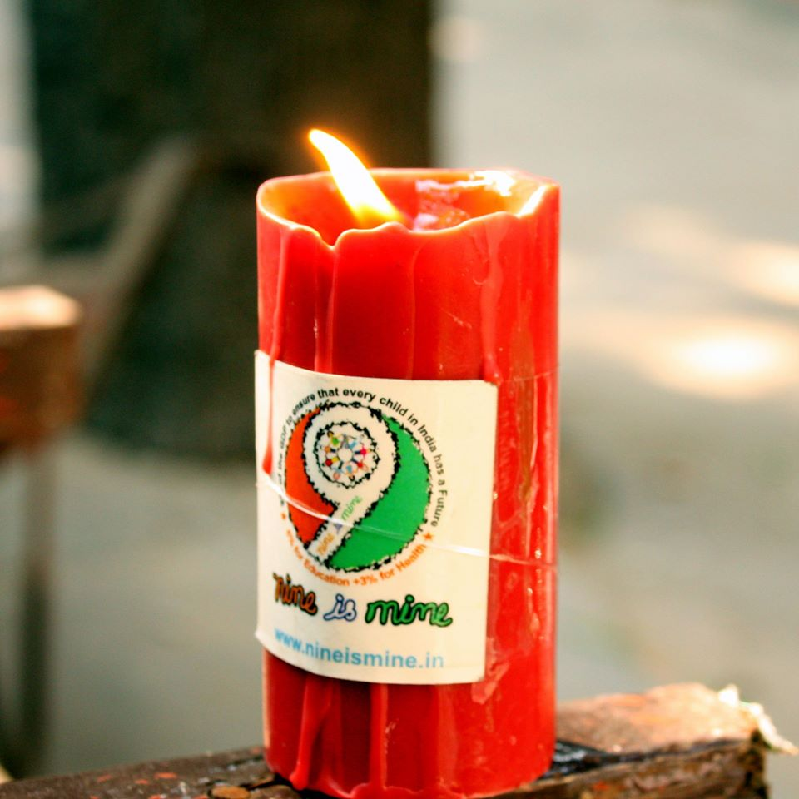
The NINEISMINE campaign is being designed as one that is of for and by the children. A child’s Right to participation through democratic means is at the heart of this initiative. Children are given platforms to speak for themselves through created child friendly media. These include juggling, circus art, mime, football, dance etc. the NINEISMINE campaign also believes that while children from marginalised situations and communities would be at the heart of its endeavours, children from privileged situations would also share these forums in the spirit of inclusion.
The NINEISMINE campaign believes that a ‘child who is capable of forming his or her own views’ has ‘the right to express those views freely in all matters affecting the child,’ and that the views of the child be given due weight ……’Even in “judicial and administrative proceedings affecting the child”. The campaign provides children to access those structures already available under our democratic system. The campaign agrees that though children ‘may not be voters…..the voices of children can be stronger than the votes of adults.’
The NINEISMINE campaign does not believe that children are ‘future citizens’ of India. It Believe that they are equal and active participants of India today. If so they have the right to participate fully in all aspects of democracy including that of “governance accountability”

The NINEISMINE campaign believes in creating platforms for all children to interact and dream of a better more Equitable and Inclusive world. However, it does believe that spaces must be created for vulnerable voices to be heard, children with access to more resources are invited to provide their spaces, talents and networks to work with rather than for their marginalized peers. The NINEISMINE campaign however, is cautions not to use children’s voices to propagate adult’s views and aspirations. Hence it has intended to keep the goals simple and non-controversial.
The NINEISMINE campaign grew out of Nelson Mandela’s call to ordinary citizens to keep governments accountable to fulfilling the MDGs. Children in India took upon themselves the task to ensure the fulfilment of Goals 2 and 3 and 4 – all of which refer to children. Later the campaign grew to realize the exclusion issue of children particularly in the context on India. They therefore incorporated a strong focus on the last child. However, keeping alive the need to ensure that all sections of India (the children of privileged middle-class and excluded communities) all interact together to find common solutions.

HAQKISHOR
Highlight: Regular advocacy training sessions with children and current issues of child rights
NINEISMINE is a campaign of for and by the children of India that attempts to train children in the art of advocacy on social issues and environment. Every month therefore the campaign attempts to gather children from varied schools and child rights organisations while providing them the skills and information of varied democratic platforms and social issues. HAQKISHOR is a pun that implies both child rights and children attempts to claim the same. These sessions are held regularly in the capital and on some occasions in varied centres in the country.
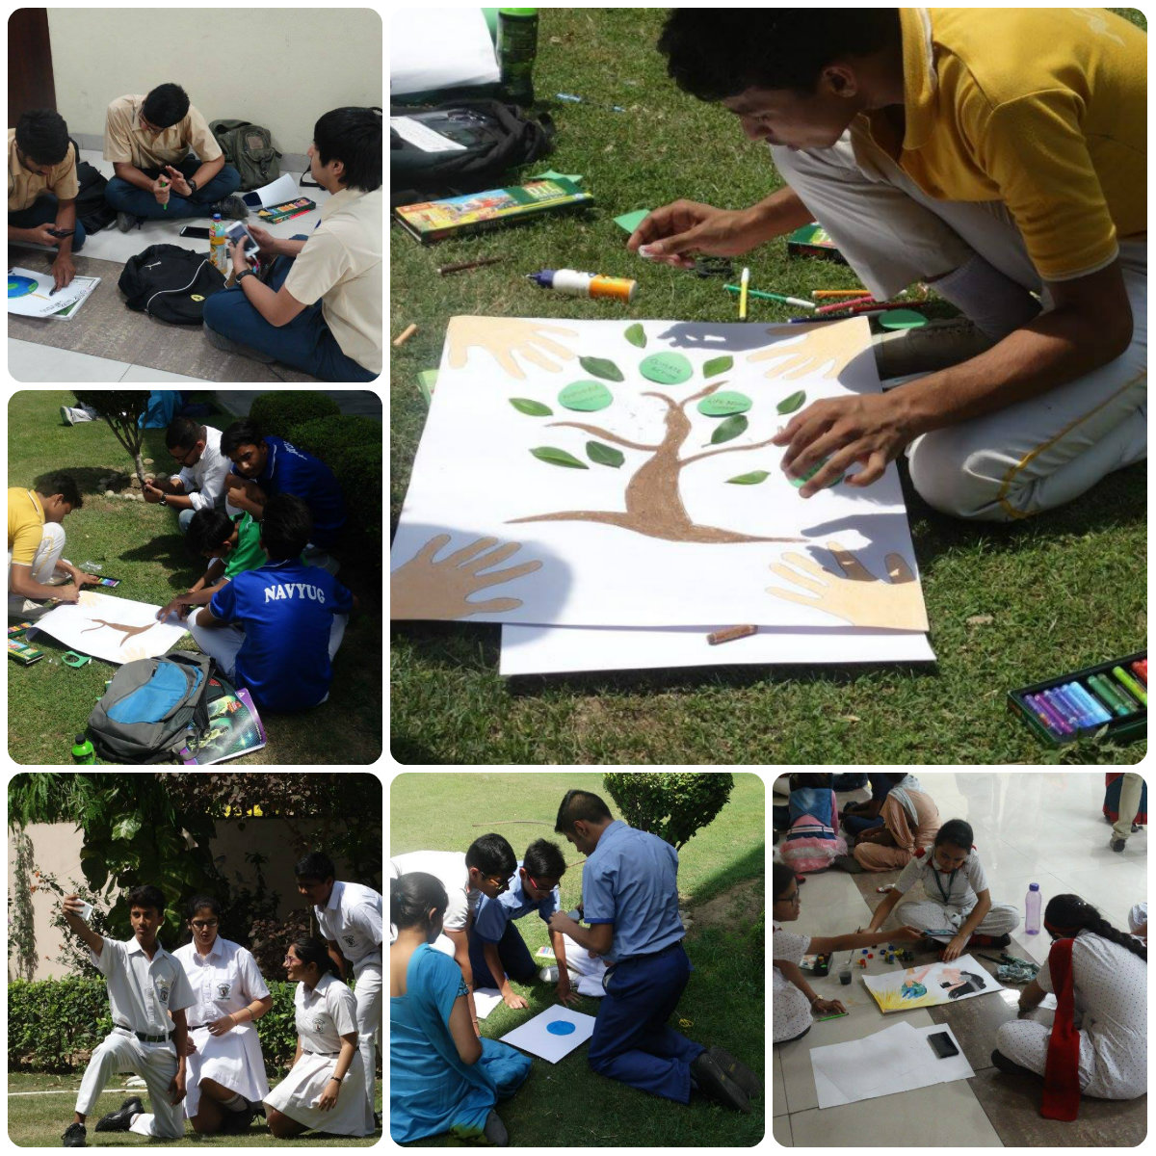

MONTHLY MAILS
Highlight: An Initiative to build the network among schools while their awareness on social issues is raised
Occasional monthly assemblies are created and circulated among schools and NGOs on relevant social issues usually on significant national and international days. This is a medium to keep the network alive and connected to the campaign. Some of the social issues touched upon are child mortality, water and sanitation, poverty, the MDGs, Nelson Mandela Day and malnutrition.

VOTE4ME UTSAV
Highlight: Use of celebrities and the media at a significantly charged moment to impact change.
Hundreds of children from various child-rights organisations and schools assembled at Jantar Mantar and rallied around various music celebrities like … This event was held on the eve of the first Day of Voting with the intent of capturing the attention of the media and the national press to conscientize the general public on the need to vote for children and to read manifestoes before reading. 11 child rights activists including Nikhil Dey, Amitabh Behar and Anita Ghai complemented the stories of 11 child-activists that exemplified their 11 demands. Musiccal bands like Eka and other musical artists lend their talent in support of the children of India.

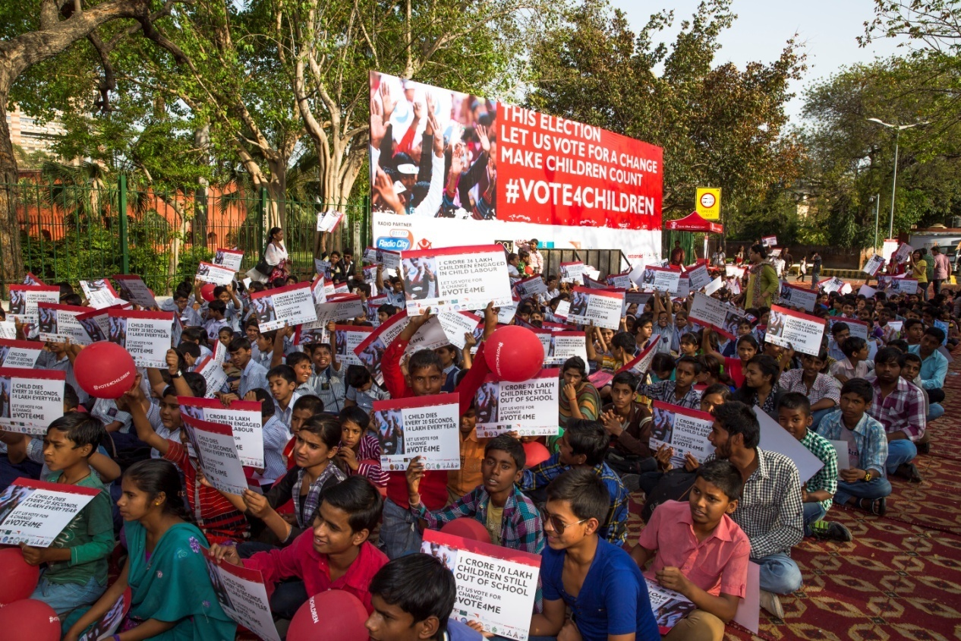

PLAY THE RIGHTS CARD
With the UNCRC entering its 25th year, it was a good time to take stock on how India has fared in implementing the Convention and more importantly what could be concrete steps for a way forward.

Taking up this challenge, UNICEF India coordinated with PRATYeK under the NINEISMINE campaign went to India’s Children to understand from how they viewed the status of their rights and that of others children in the country.
In a unique and innovatively designed survey, children rated achievements (or lack of them) for 45 of the articles of the UNCRC.

The result is captured in the book called PLAY THE RIGHTS CARD Children’s Opinion on the convention on the Rights of the Child. There is frank and sharp assessment on some issues, there are also kudos for others and most importantly, suggestion on a way forward.
The Idea of engaging children in a nationwide poll promotes Article 12 of the Convention that highlights a child right ‘to be heard’ and that these opinions and suggestions must be given due weight. This children’s survey of child rights was intended as a tool to provide children (the key stakeholders of the UNCRC) with a platform not only for expressing their experiences, suggestions, but also providing them with a means of knowing and engaging with the duty bearers or defenders of these rights.
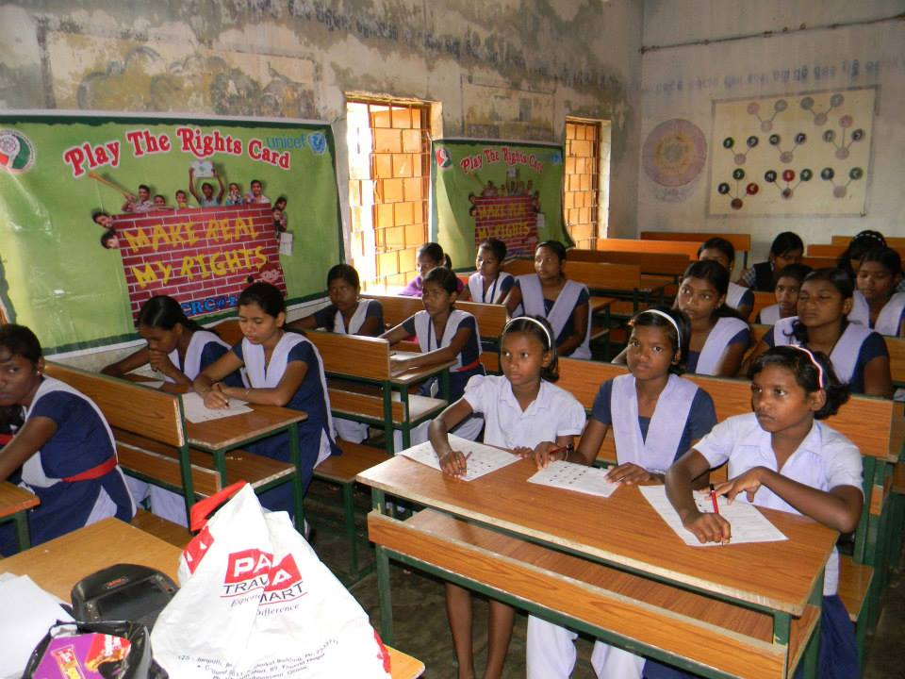
This survey reached out to a total 10,000 students between 14 to 17 years. Majority of children were in secondary school and most listed being a student as their primary occupation.
The survey stressed on the qualitative approach so that in-depth information on the views and voices, on all articles under the UNCRC and issues related to children’s expression of opinions could be gathered.

Because the poll was both executed and conducted by children, the methodology needed to be simple and short. Workshops were held in groups of 50. Rather that all rights evaluated by the entire group, a set of six rights were examined by a group of six and seven children.

PRATYeK SOCIAL JUSTICE AWARDS
Highlight: An Initiative to recognise justice initiatives among children
Children from various schools and NGOs are invited to submit reports on their engagement with social issues. The awards are an attempt to recognise and nature the spirit of justice an advocacy among young people even as they are encouraged to engage with and skill themselves for the same. There progressive range of awards varying from simple charitable engagements to long-term engagement in human rights issues.
This year the awards went to Surbhi from Loreto School New Delhi.

NELSON MANDELA DAY
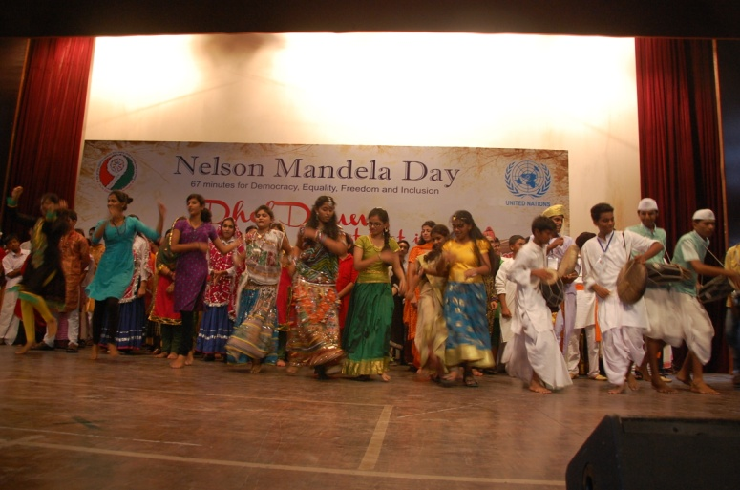
The birth anniversary of Mandela, the man at the heart of the MAKEPOVERTYHISTORY campaign and in response to which the NINEISMINE campaign came into existence. It is on his birth anniversary that the UN invites people to commit themselves to 67 minutes of social Justice.
This becomes an ideal occasion to gather the UN agencies in India under one banner even as they invite children to respond to social issues particularly those related to children.
On 18th July 2015, around 1000 children from various schools of Delhi along with students from all parts of India assembled at Convent of Jesus And Mary School, Bangla Sahib, where students and their Madiba spend 67 minutes to shake the world with the dhols drum of Apathy and realise the UN Millenniums Developments Goals to Halve poverty by 2015, the event was called DHOL DRUMS Just beat it, a attempt to creatively use the drums to call for the inclusion and justice for all children and to promote Mandela values of Democracy, Justice Freedom (and Inclusion).
The occasion also became a host to the workshop that was a follow up action plan to the UN Public Lecture on Domestic Workers by Country Chief of ILO and Child advocates conducted a premier run of their unique “HOME WORK MATTERS” game, designed as a lobbying tool towards getting India to sign the ILO convention on Domestic Workers.

CHILD RIGHTS DAY
Along with Save the Children 25 schools from Delhi were invited to Delhi Hut apposite INA market. After engaging with stories from children from the margins and representative from the NCPCR the children then came back and sat in mix groups to depict their dreams or their appeals to various defenders of child rights through the medium of art. These stories were finally presented by the children to the UNICEF; Child rights Activists and child activists.

ACTION 2015
ACTION 2015 was a global movement for change that gathered more than 2200 organisations around the globe.
With 31 million campaign’s action taken in 157 countries, ACTION 2015 was a massive global movement to demand world leaders do their part to tackle the most pressing issues of our time. The year 2015 was time for world leaders to show ambition and turn the commitments made for 2015 into reality for millions of people around the world.
On 14th January 2015 ACTION 2015 was launched in over 60 countries around the world.
A group of 15 children aged 15 years from 15 different states gathering at Vishwa Yuva Kendra, New Delhi to kick off the campaign in India in presence of Najma Heptulla Union Minister for Minority Affairs. The movement aimed to influence the next development framework with aspirations of people and children from around the world.
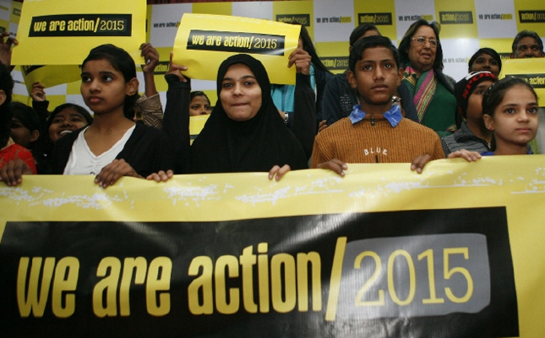

NATIONAL CHILDREN PARLIAMENT
Each year representatives from various schools and child rights organisations gather in the capital to receive training in the art of organising Children’s parliaments. The General Elections for various ‘parliamentary posts’ are held for tenure of three years with bye elections being held each year. This children’s parliament would also deliberate on local and national themes and campaign focus for the year like framing Children’s Manifestoes, Reporting to the UN CRC and the UN UPR and stocktaking on National Children’s Policies and State and National Political Manifestoes and Un SDGs/MDGs. The expertise of Fr Edwin John from NCN is tapped along with his team which includes young ‘parliamentarians’. The expertise of Fr Edwin John was tapped and he along with his teams including young ‘parliamentarians’ conducted the workshop. This training has resulted in the conducting of vibrant parliaments
( see appendix)

CHILDREN IN THE REPUBLIC
Each year to coincide with the Public Day Gathering in the National capital the NINEISMINE organises a panel of child rights activists to share with the participating members of the National Children’s Parliament on the current issues of child rights in India and related laws, policies and budgets that enhance or hinder the same

STATE COORDINATORS MEET
Each year staffs of schools or child rights organisations are brought together to the National Capital for an orientation program on forthcoming events and for an evaluation on pervious campaign activities. These workshops strengthen the network even as they work as capacity building exercises for the members of the network. This workshop also deepens the ownership of the campaign by members in the designing and execution of the activities. This year the state coordinators meet was held in conjunction with the National Children’s parliament and public day. The adult escorts from different NGOs met regularly to give feedback on the past activities of NINEISMINE campaign and planning the way forward

WE THE CHILDREN
After days of intense discussions on issues related to children the children are invited to share their opinions on concurrent themes in the style of a public debate organised and conducted by children themselves. We the children also brings in politicians, child rights activists and the media to listen to the voice of children and equal and active members of our democracy with the right ‘To Speak and to be Heard’ and for their opinions to be taken seriously’ (CRC Art 12). Colin Gonsalves the Director of Human Rights Law Network presided at the event and swore in the new children’s Parliament. Paul Devakar from WNTA, Beena from Swadhikar, Sundeep Narwani from AAP and Amitabh Behar Co-chairperson of GCAP were among those present at the event.

PUBLIC DAY 2015
The Public Day celebration was organized on 2nd February 2015 which was also the culmination of the Global Action 2015 launch. Children from various parts of India along with students from schools and volunteers from different colleges in Delhi celebrated the Public Day.
30th January is marked as the NINEISMINE’s Public Day honouring the death anniversary of our Mahatma Gandhi the man who stood for “Antyodaya” which means “development from the last man”. 30th January is also relevant because after the nation culminates its National Republic day celebrations where the poor and socially marginalized people are conspicuously absent, it’s a celebration of the last human being. Lastly the relevance of the celebration is marked by the fact that it is just about a month before the country announces its annual budget. Children from numerous schools and civil society organizations that represented varied child-rights issues joined the children’s social forum that called for a budget that reflects a stronger commitment towards the last child. Using different medium of expressions like street plays, flags, drums, posters, slogans, puppets, unicycles, and varied regional dances, children highlighted the issues of children of India. The children also kept one minutes silence in honour of their Bapu by gesturing Gandhi’s Three Monkeys to symbolize children. India’s millions of children who are not given age appropriate forums to speak or whose voice goes unheard and those who still live in bondage in varied degrees.

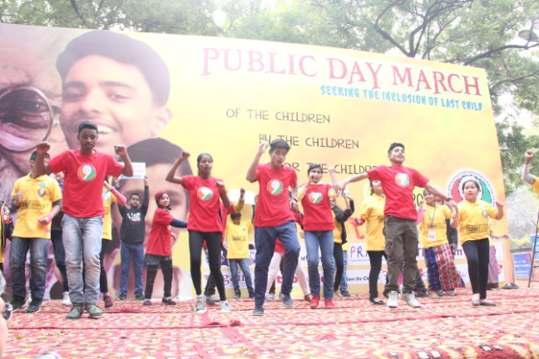
Flash Mob by NINEISMINE’s young Activists for the call 9%

Approximately 7,500 children from various sections of Delhi joined by representatives of 27 states and union territories who had gathered in the national capital for the culmination of the Global Action 2015 launch. These children who were largely in their teens assembled at Jantar Mantar to seek the fulfilment of the Millennium Development Goals that are due, to be delivered by the end of this year. Children from several NGO’s, and institutions for children with disabilities, private schools and government schools along with escorts and social activists also attended the event.

Various NGO’s were provided Platform to raise different issues

• Mrs Annie Namala the Director of CSEI launched the Up for School global campaign which draws attention to ensure that every child has access to equitable quality education. Mrs Namala added that ‘in India the campaign is to draw in the children of socially excluded communities.’

• Paul Diwakar, the Director of NCDHR and the National Convener of the Wada Na Todo Abhiyan which leads the NINEISMINE campaign called for a deliberate focus on children from vulnerable communities in our Budgets. With little over 60 days left for the 31st of March, Ambarish Rai called for the complete implementation of the Right to Education by the set deadline.

• Ms Sehjo from Action Aid introduced Beti Zindabad campaign, which talks about issues related to girls and security of girl child. Beti Zindabad bookmarks were distributed to all the children and people present for the event. A young girl read out the quote from the bookmark “As good and responsible human beings, we respect and recognize equality for every girl and woman.”

• Amitabh Behar the global co-chair of the Action 2015 Launch said that this gathering joined the energy of similar gathering across 80 nations of the world. He also said “We as the children and young people should demand historic action from our national and global leadership to make a transformative change to ensure justice, peace and suitability in the world through an ambitious SDGs and climate convention in DEC 2015.”

• Ms. Devika talked about one Billion Rising campaign, a biggest mass action to end violence against women and rise in defiance of the injustice that women suffer.

Achievements during the year
Interaction with Mrs You Soon-taek (Ban ki Moon)
During His Excellency Ban Ki moons visit to India in January her office approached the NINEISMINE seeking an interaction with the children of the campaign. The children presented snippets of their campaign and their call. They sought her help in promoting the campaign by connecting with the UN Secretary General, British ex PM Gordon Brown, Malala and ex UNGA Mr Kofi Anana.

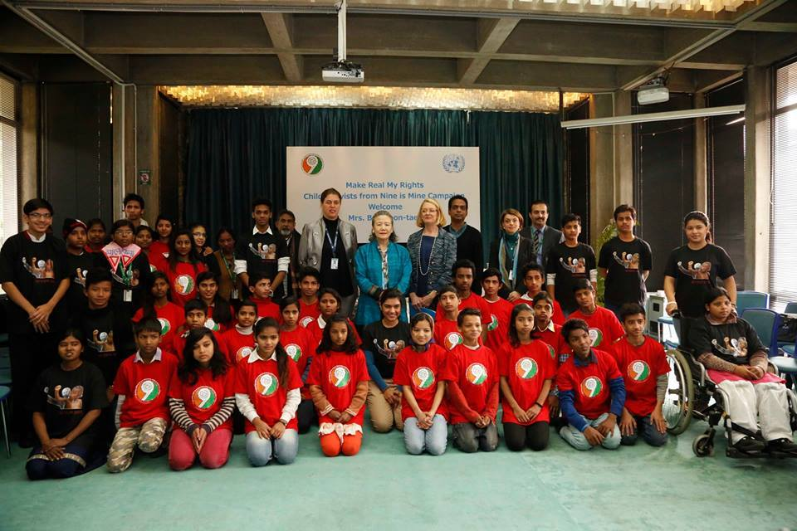
Recipient of United Nations Special Recognition Award
During their visit to the UN headquarters in New York during the UN General Assembly in 2013 when the world leaders had assembled to both to evaluate the MDGs even as they charted out the new SDGs. The NINEISMINE were recognised for their efforts at collating the voice of 120,000 children in India as well as for promoting consultations with children as a right. At numerous UN official gatherings the NINEISMINE was quoted as a ‘Best Practice’ like at the Bali UN working Open group. Recently the campaign also received an award from the United Nations Women in appreciation of its works.

